**Excel Assignment - 11**

1. Use the below table for the following Questions.

1. Find the Minimum Marks and Maximum marks scored by each student.

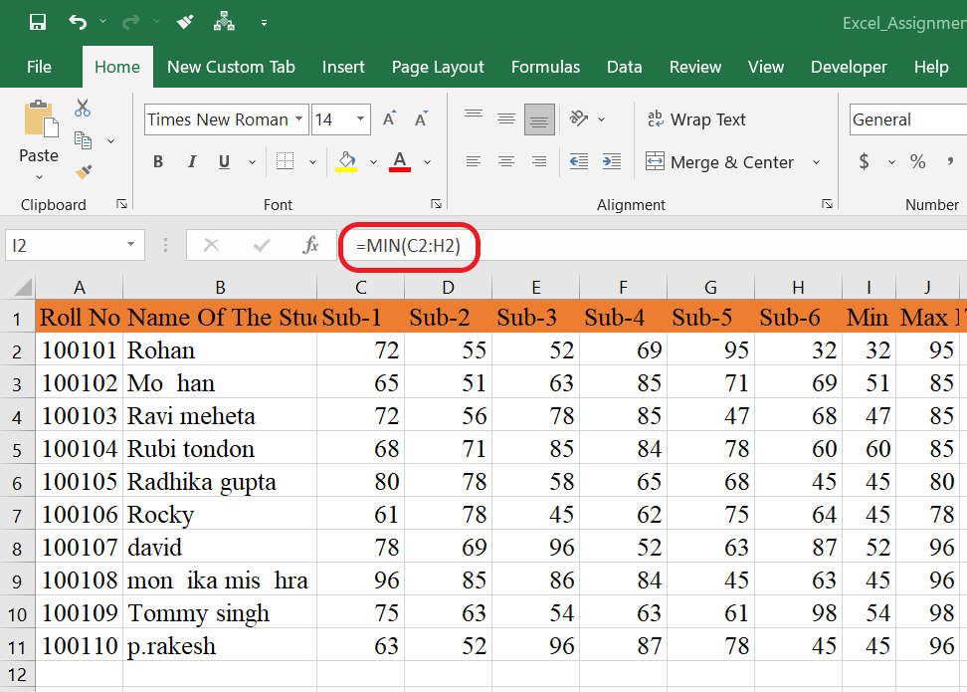

2. Calculate the totals for each student, use conditional formatting to

highlight the top students who have scored more than 480.

There are not a single student have total score of 480 so no cell was highlighted. If we take 417 instead of 480 then result may be different that shows after the below img.

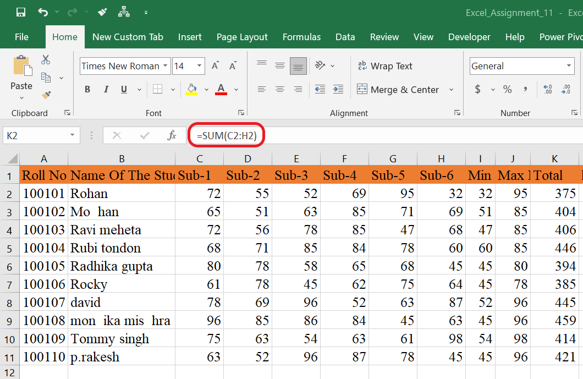

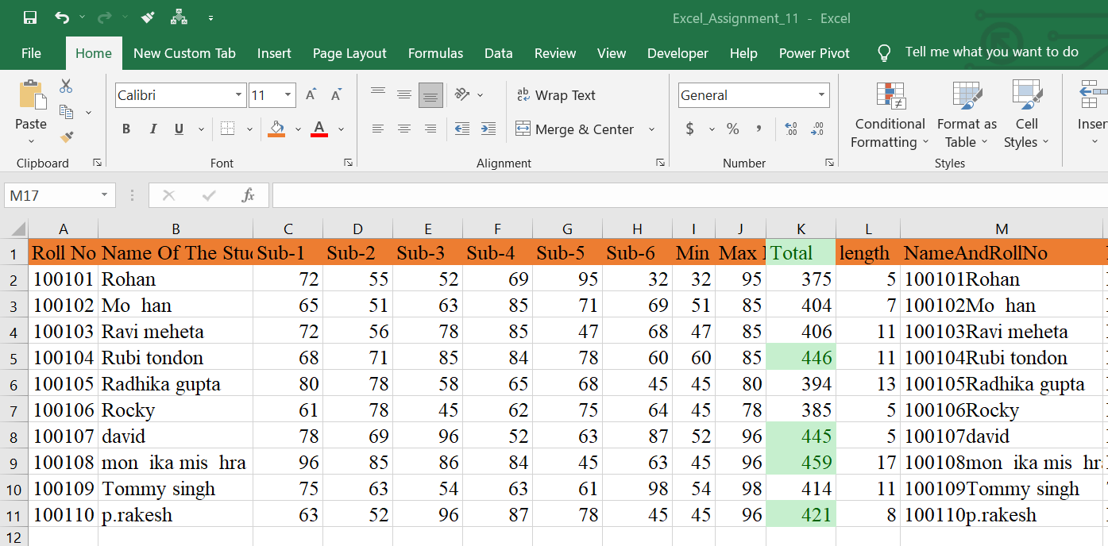

3. Calculate the length of the names of each student.

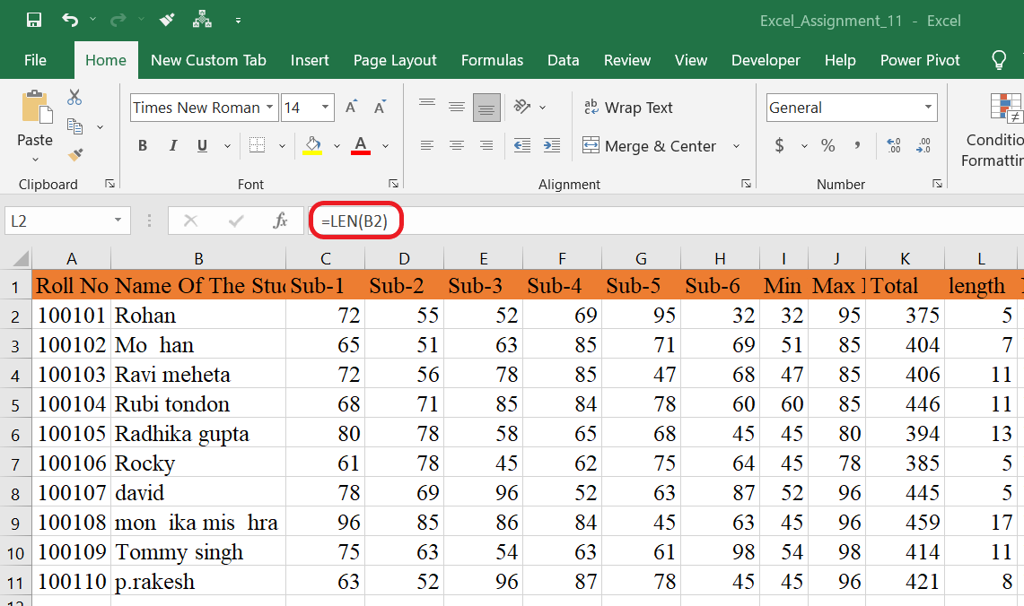

4. Replace the Name Rakhi with Rocky. Use Formulas

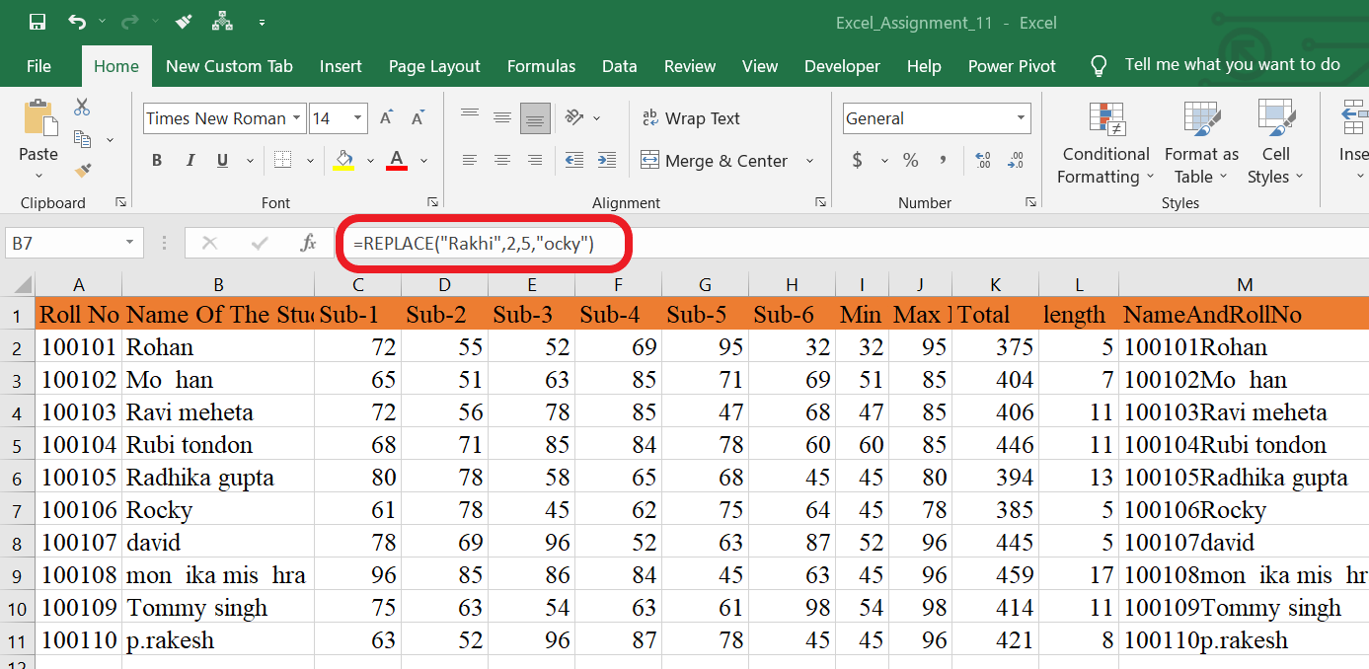

5. Combine the Roll Numbers and Names. Use formulas. The end result should look like below . 100101Rohan

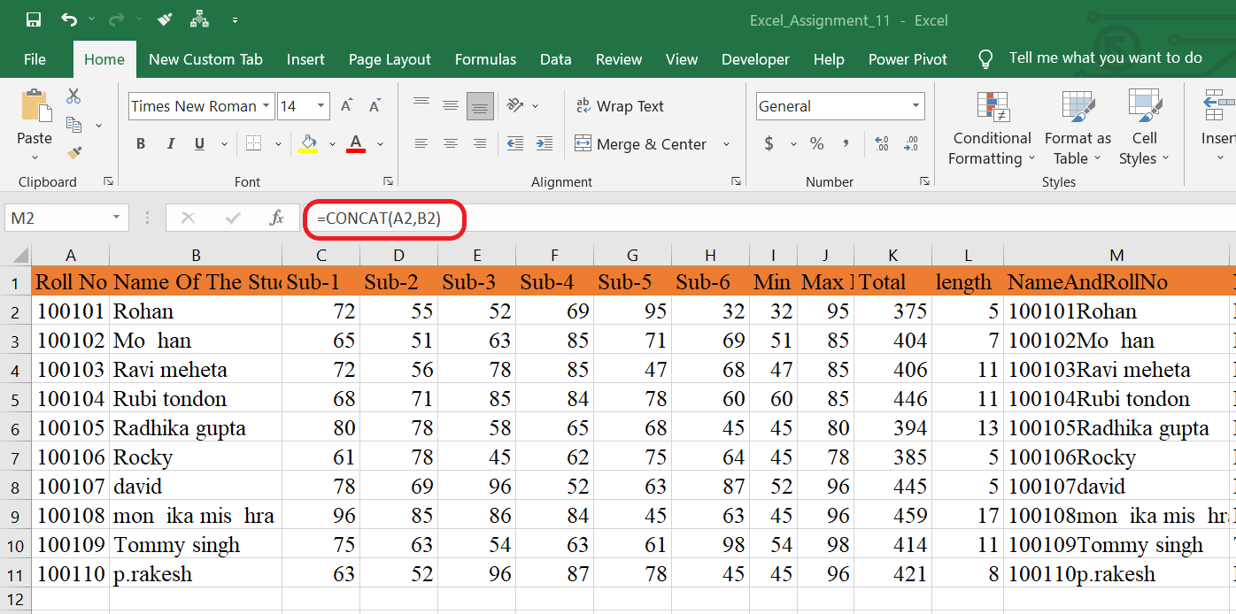

6. As you can see that some names have spacing issues. Use Formulas to correct that spacing. Also ensure that the names and surnames start with a capital letter

